**IC3 2019 Winter Retreat**

February 14-15, 2019 Congress Centre Kursaal Interlaken, Strandbadstrasse 44, 3800 Interlaken, Switzerland

IC3 faculty, students, sponsors and guests gather at IC3 Retreats to discuss the major technical challenges, issues and innovative solutions to widespread blockchain adoption. The 2019 Winter Retreat was in Switzerland with our IC3 colleagues from ETH Zurich and EPFL, as well as all other IC3 campuses (Cornell, Cornell Tech, UC Berkeley, UCL, UIUC, and the Technion).

The Retreat was on February 14-15, and co-located at Interlaken with the [Swiss Blockchain Winter School](https://blockchainschool.epfl.ch) on February 11-14.

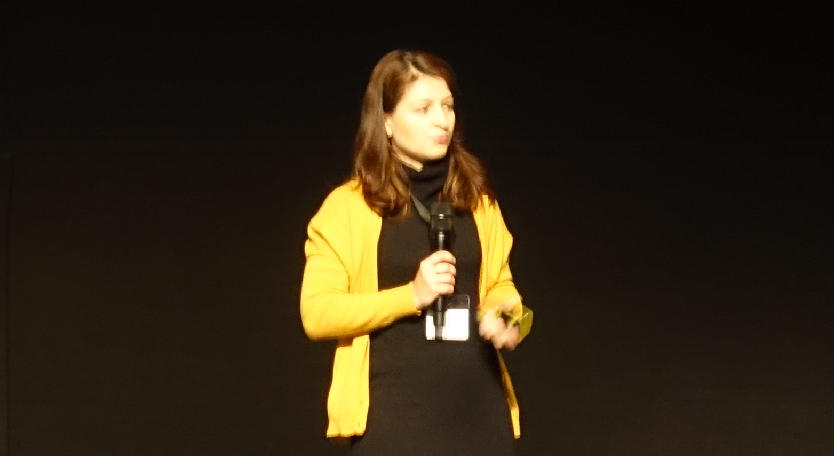**Cristina Basescu (EPFL) kicked off the Retreat with the talk “Low-latency and locality-preserving blockchains”**

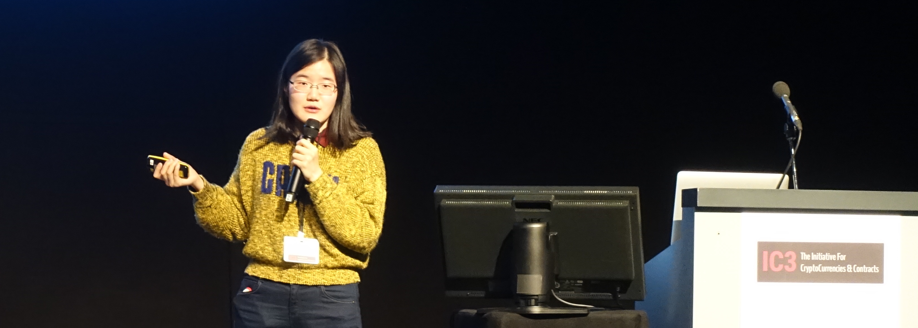

**Yan Ji (Cornell) presents “Amplification of selfish mining in fraud-proof based blockchains”**

There were several talks by women researchers in the blockchain community; notably Cristina Basescu (EPFL), Yan Ji (Cornell), Dahlia Malkhi (VMware), Mary Maller (UCL), and Christine Moy (JP Morgan).

 **Clear skies and temperatures above 50F lured attendees outside during the breaks. At right is the view from Interlaken of Jungfrau (11,600 feet), also known as the “Roof of Europe”.**

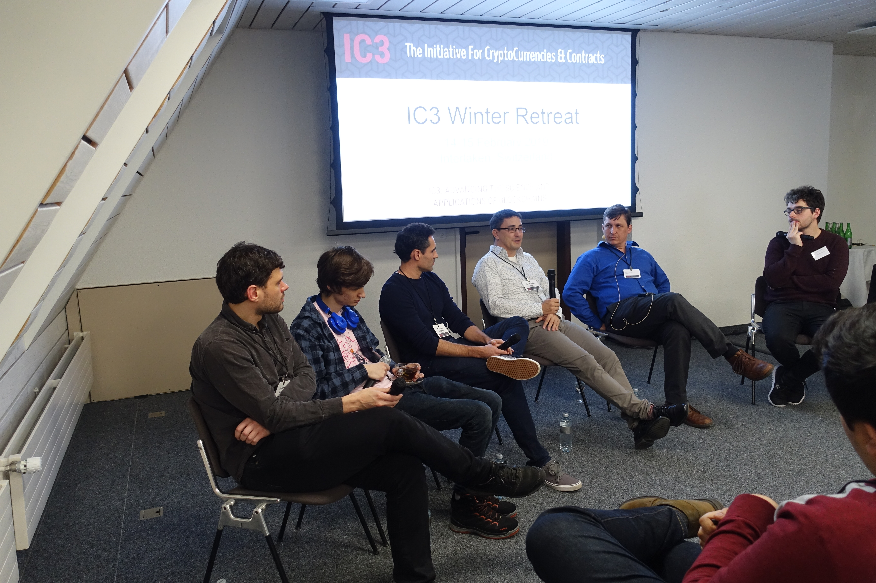

**The panel discussion “Too much infrastructure: not enough use-cases or usability studies?” was led by Prof. Patrick McCorry (Kings College London).**

Left to right are seated Prof. Andrew Miller (UIUC), Phil Daian (Cornell), Tyrone Lobban (JP Morgan), Prof. Emin Gun Sirer (Cornell), Bob McElrath (Fidelity), and Prof. McCorry.

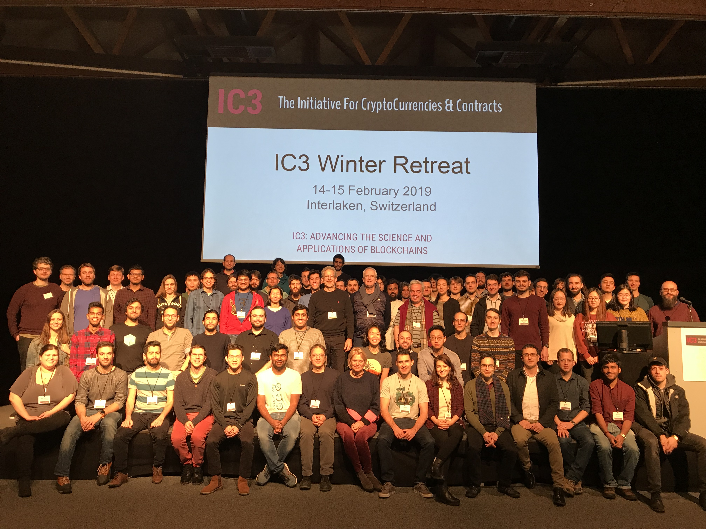

**Attendees gathered for a group photo on the final day of the Retreat.**

**IC3 Winter Retreat Agenda**

|  |  |
| --- | --- |
| **Thursday**    8:00 - 8:45 | Continental Breakfast |
| 8:45 - 9:00 | Welcome - Ari Juels |
| 9:00 - 10:00 | Blockchains at Scale I - 10 minute talks (8 minutes + QA) – Session Chair: Andrew Miller |
|  | Cristina Basescu - Low-latency and locality-preserving blockchains  Oded Naor - Teechain: A Secure Asynchronous Blockchain Payment Network  Patrick McCorry - Scaling Cryptocurrencies via State Channels  Mustafa Al-Bassam - Replay attacks against cross-shard communication protocols  Yan Ji - Amplification of selfish mining in fraud-proof based blockchains |
| 10:00 - 10:30 | Break - 30 mins |
| 10:30 - 11:10 | Blockchain at Scale II - 10 minute talks (8 minutes + QA) - Session Chair: Emin Gun Sirer |
|  | Enis Ceyhun Alp - Heterogeneous sharded blockchain architecture  Karl Wust - ZLiTE: Lightweight Clients for Shielded Zcash Transactions using Trusted Execution  Sergi Delgado Segura - TxProbe: Discovering Bitcoin's Network Topology Using Orphan Transactions  Surya Bakshi - Erays: Reverse Engineering Ethereum's Opaque Smart Contracts |
| 11:10 - 12:00 | Start-ups emerging from IC3 - 10 minute talks (8 minutes + QA) – Session Chair: Patrick McCorry |
|  | Sergey Nazarov - Town Crier and Decentralised Oracles  Kevin Sekniqi - Avalanche  Lun Wang - Oasis Labs  Soumya Basu - bloXroute |
| 12:00 - 13:30 | Lunch |
| 13:30 - 14:30 | Cryptography and Zero Knowledge - 10 minute talks (8 minutes + QA) – Session Chair: Andrew Miller |
|  | Jiaheng Zhang  & Tiancheng - Faster zero-knowledge interactive proofs  Mary Maller - Improvements to Updatable CRS  Samarth Kulshreshtha - Scaling Asynchronous Multi-Party Computation: A Systems Perspective  Kevin Liao - A Calculus for Composable, Computational Cryptography  Tom Yurek - Client-efficient Asynchronous Verifiable Secret Sharing and Anonymous Broadcast  Krishna Deepak Maram Lun Wang - CHURP: CHUrn-Robust Proactive secret sharing |
| 14:30 - 15:00 | Break - 30 minutes |
| 15:00 - 15:45 | Panel: Too much infrastructure, not enough use-cases/usability studies? – Moderator: Patrick McCorry,  Panelists: Phil Daian (Cornell/IC3), Andrew Miller (UIUC/IC3), Tyrone Lobban (JP Morgan), Bob McElrath (Fidelity), Emin Gun Sirer (Cornell/IC3) |
| 15:45 - 17:00 | Industry and Community Use Cases - 10 minute talks (8 minutes + QA) – Session Chair: Jim Ballingall |
|  | Dahlia Malkhi – VMware - Consensus Protocols  Angelo De Caro – IBM - Hyperledger Fabric Update  Michael Steiner - Intel - SGX Update  Jorge Cuellar – Siemens – Blockchains and IoT  Bob McElrath - Fidelity  Sascha Hanse - Aeternity  Nicola Greco - Protocol Labs **-** Filecoin  Simon Meier - Digital Asset Holdings - DAML  Christine Moy - JP Morgan – The Quorum Ecosystem |
| 17:00 - 18:00 | Networking Reception |
| 18:00 - | Dinner |

|  |  |
| --- | --- |
| **Friday**    7:15 - 8:00 | Continental Breakfast |
| 8:00 – 9:00 | Proof-of-Personhood (Audience Participation Session) – Bryan Ford and Linus Gaser |
| 9:00 - 10:00 | Consensus Protocols (Attacks, Defense, Models) - 10 minute talks (8 minutes + QA) – Session Chair: Ittay Eyal |
|  | Kevin Negy & Sishan Long - Selfish Mining  Itay Tsabary - Gap game  Sanket Kanjalkar - “I Can’t Believe It’s Not Stakes”  Jian Liu - Saber: sharding by separating execution from consensus  Ethan Cecchetti - PIES and Proof of Replication  Phil Daian - The Dark Side of Blockchain - HFT, Bribery, Consensus Attacks, and More |
| 10:00 - 10:30 | Break - 30 mins |
| 10:30 - 11:10 | Reinforce Industrial use cases - 10 minute talks (8 minutes + QA) – Session Chair: Ari Juels |
|  | Elefteris Kokoris-Kogias - Calypso on-chain secrets & policy enforcement  Tyler Kell - Lib-submarine  Kai Mast - Sharding blockchains  Alex Manuskin - Client Architecture |
| 11:10 - 11:30 | Standup of New Ideas and Research Directions – Session Chair: Andrew Miller |
| 11:30 - 11:45 | Closing Remarks – Emin Gun Sirer |